Faculty of Computing

CS-272 Artificial Intelligence
BSCS-15DE

Lab 2: Uninformed Search

Date: 17-09-2026

Lab Engineer: Ms. Shakeela Bibi
Instructor: Dr. Sohail

Lab 2: Uninformed Search

Implement Questions 1 and 2 from http://ai.berkeley.edu/search.html , which are also reproduced below.

Note: You can work in groups of 2 but not more than 2.
Deliverables: Submit search.py
Deadline: Will be decided at the end of the lab

Download the code from the above-mentioned website.

Table of Contents

- Introduction
- Welcome
- Q1: Depth First Search
- Q2: Breadth First Search

Introduction
In this project, your Pacman agent will find paths through his maze world, both to reach a particular location and to collect food efficiently. You will build general search algorithms and apply them to Pacman scenarios.

This project includes an autograder for you to grade your answers on your machine. This can be run with the command:

python autograder.py
See the autograder tutorial in Project 0 for more information about using the autograder.

The code for this project consists of several Python files, some of which you will need to read and understand in order to complete the assignment, and some of which you can ignore. You can download all the code and supporting files as a zip archive.

Files you'll edit:
search.py | Where all of your search algorithms will reside.
searchAgents.py | Where all of your search-based agents will reside.
Files you might want to look at:
pacman.py | The main file that runs Pacman games. This file describes a Pacman GameState type, which you use in this project.
game.py | The logic behind how the Pacman world works. This file describes several supporting types like AgentState, Agent, Direction, and Grid.
util.py | Useful data structures for implementing search algorithms.
Supporting files you can ignore:
graphicsDisplay.py | Graphics for Pacman
graphicsUtils.py | Support for Pacman graphics
textDisplay.py | ASCII graphics for Pacman
ghostAgents.py | Agents to control ghosts

keyboardAgents.py | Keyboard interfaces to control Pacman
layout.py | Code for reading layout files and storing their contents
autograder.py | Project autograder
testParser.py | Parses autograder test and solution files
testClasses.py | General autograding test classes
test_cases/ | Directory containing the test cases for each question
searchTestClasses.py | Project 1 specific autograding test classes

Files to Edit and Submit: You will fill in portions of search.py and searchAgents.py during the assignment. You should submit these files with your code and comments. Please do not change the other files in this distribution or submit any of the original files other than these files.

Welcome to Pacman

After downloading the code (search.zip), unzipping it, and changing to the directory, you should be able to play a game of Pacman by typing the following at the command line:

python pacman.py

Pacman lives in a shiny blue world of twisting corridors and tasty round treats. Navigating this world efficiently will be Pacman's first step in mastering his domain.

The simplest agent in searchAgents.py is called the GoWestAgent, which always goes West (a trivial reflex agent). This agent can occasionally win:

python pacman.py --layout testMaze --pacman GoWestAgent

But, things get ugly for this agent when turning is required:

python pacman.py --layout tinyMaze --pacman GoWestAgent

If Pacman gets stuck, you can exit the game by typing CTRL-c into your terminal. Soon, your agent will solve not only tinyMaze, but any maze you want.
Note that pacman.py supports a number of options that can each be expressed in a long way (e.g., --layout) or a short way (e.g., -l). You can see the list of all options and their default values via:

python pacman.py -h

Also, all of the commands that appear in this project also appear in commands.txt, for easy copying and pasting. In UNIX/Mac OS X, you can even run all these commands in order with bash commands.txt.

Note: if you get error messages regarding Tkinter, see this page.

Question 1: Finding a Fixed Food Dot using Depth First Search
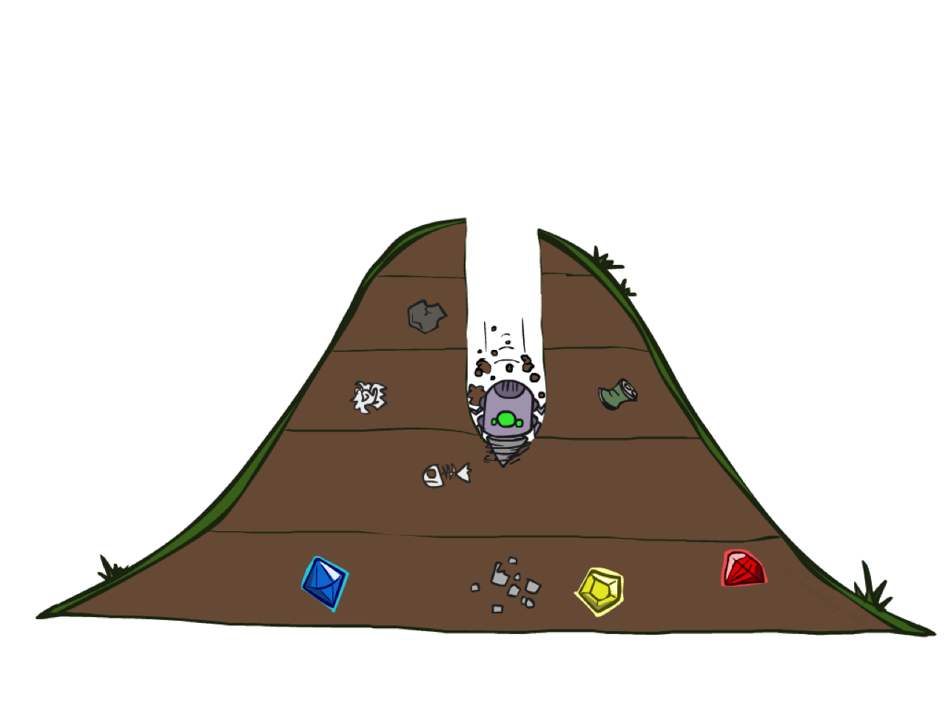
DFS

In searchAgents.py, you'll find a fully implemented SearchAgent, which plans out a path through Pacman's world and then executes that path step-by-step. The search algorithms for formulating a plan are not implemented -- that's your job. As you work through the following questions, you might find it useful to refer to the object glossary (the second to last tab in the navigation bar above).

First, test that the SearchAgent is working correctly by running:

python pacman.py -l tinyMaze -p SearchAgent -a fn=tinyMazeSearch

The command above tells the SearchAgent to use tinyMazeSearch as its search algorithm, which is implemented in search.py. Pacman should navigate the maze successfully.

Now it's time to write full-fledged generic search functions to help Pacman plan routes! Pseudocode for the search algorithms you'll write can be found in the lecture slides. Remember that a search node must contain not only a state but also the information necessary to reconstruct the path (plan) which gets to that state.

Important note: All of your search functions need to return a list of actions that will lead the agent from the start to the goal. These actions all have to be legal moves (valid directions, no moving through walls).

Important note: Make sure to use the Stack, Queue and PriorityQueue data structures provided to you in util.py! These data structure implementations have particular properties which are required for compatibility with the autograder.

Hint: Each algorithm is very similar. Algorithms for DFS, BFS and A* differ only in the details of how the fringe is managed. So, concentrate on getting DFS right and the rest should be relatively straightforward. Indeed, one possible implementation requires only a single generic search method which is configured with an algorithm-specific queuing strategy. (Your implementation need not be of this form to receive full credit).

Implement the depth-first search (DFS) algorithm in the depthFirstSearch function in search.py. To make your algorithm complete, write the graph search version of DFS, which avoids expanding any already visited states.

Your code should quickly find a solution for:

python pacman.py -l tinyMaze -p SearchAgent python pacman.py -l mediumMaze -p SearchAgent python pacman.py -l bigMaze -z .5 -p SearchAgent

Lab Task 4: Self-Driving Electric Vehicle (EV) Design

Use your creativity and out-of-the-box thinking to design a complete system model for a self-driving electric vehicle (EV). The goal is to integrate AI agents to enhance the vehicle’s functionality and make it fully autonomous.

Instructions:

- System Design: Develop a comprehensive system architecture for a self-driving EV. Consider key components such as sensors, actuators, processors, and controllers.

- AI Agents: Integrate AI agents to automate various tasks within the EV. Examples of AI agents you can design include:
• Collision Avoidance Agent: To detect and avoid obstacles in real-time.
• Automatic Wiper Agent: To activate windshield wipers automatically based
on weather conditions.
• Lane Keeping Agent: To ensure the car stays within its lane.
• Speed Control Agent: To adjust speed according to traffic conditions and road regulations.

- Note: Add 5th agent which shows your creativity (never seen before). This AI-agent can enhance the vehicle’s safety, convenience, or energy efficiency.

The Pacman board will show an overlay of the states explored, and the order in which they were explored (brighter red means earlier exploration). Is the exploration order what you would have expected? Does Pacman actually go to all the explored squares on his way to the goal?

Hint: If you use a Stack as your data structure, the solution found by your DFS algorithm for mediumMaze should have a length of 130 (provided you push successors onto the fringe in the order provided by getSuccessors; you might get 246 if you push them in the reverse order). Is this a least cost solution? If not, think about what depth-first search is doing wrong.

Question 2: Breadth First Search
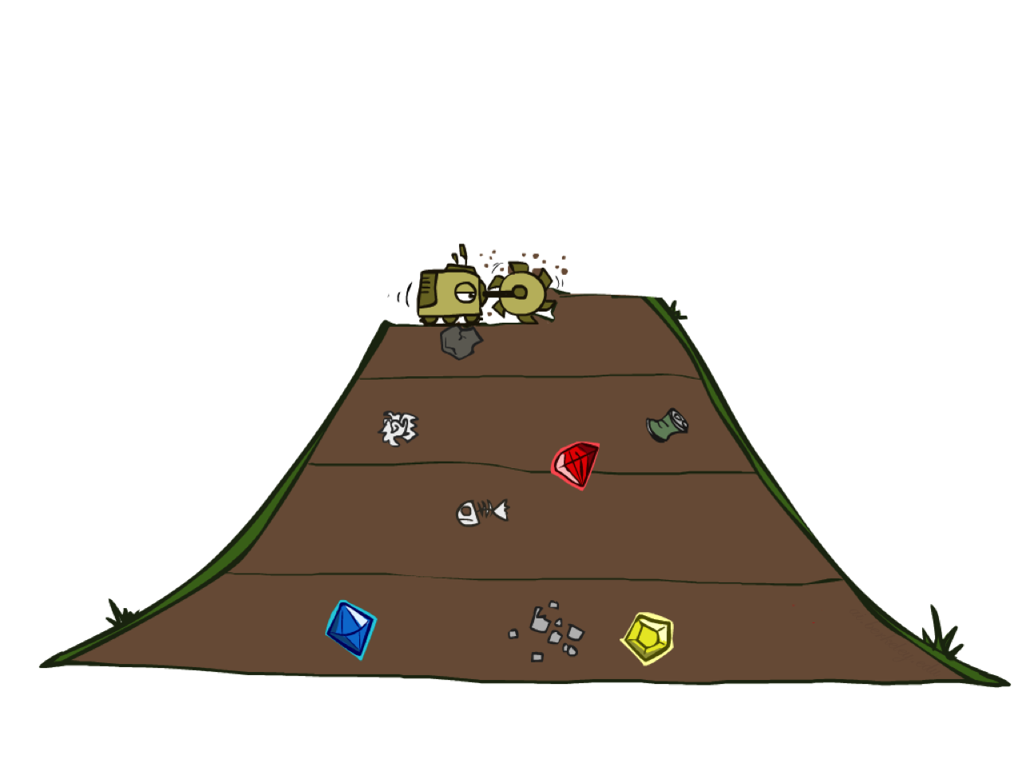
BFS
Implement the breadth-first search (BFS) algorithm in the breadthFirstSearch function in search.py. Again, write a graph search algorithm that avoids expanding any already visited states. Test your code the same way you did for depth-first search.

python pacman.py -l mediumMaze -p SearchAgent -a fn=bfs python pacman.py -l bigMaze -p SearchAgent -a fn=bfs -z .5

Does BFS find a least cost solution? If not, check your implementation.

Hint: If Pacman moves too slowly for you, try the option --frameTime 0.

Note: If you've written your search code generically, your code should work equally well for the eight-puzzle search problem without any changes.

python eightpuzzle.py

